November 20, 2019

Dear Congressman Brown,
Congratulations! We are thrilled to announce that you have received the 2020 cycle endorsement of the Planned Parenthood Action Fund. You have demonstrated strong support for sexual and reproductive health and rights, and we feel confident you will be a dedicated advocate for Planned Parenthood health centers and the people they serve when you are elected to the House in 2020.
Please note that Planned Parenthood health centers and Planned Parenthood Federation of America (PPFA) are 501(c)(3) organizations and do not intervene in elections. If you chose to share the news of our endorsement with others, please convey that you were endorsed by the Planned Parenthood Action Fund, and not “Planned Parenthood,” “PPFA” or any other Planned Parenthood organization.
As a candidate endorsed by Planned Parenthood Action Fund, you have the opportunity to use our endorsement seal during this election cycle. For more information about how to access and use this seal, please read and sign our 2020 cycle Endorsement Seal Agreement. Once you complete the form, you will receive an email with our seal attached.

We will be announcing the endorsement among a slate of candidates on social media and in a press release on Tuesday December 3. If you do not wish to be included in our public rollout, please let us know by Friday November 29.

If you have any questions, please reach out to PPAF National Political Director Yasmin Radjy at yasmin.radjy@ppfa.org and PAC Manager Nikki Goldschein at nikki.goldschein@ppfa.org.

Congratulations again! We are proud to stand with you.

Sincerely,
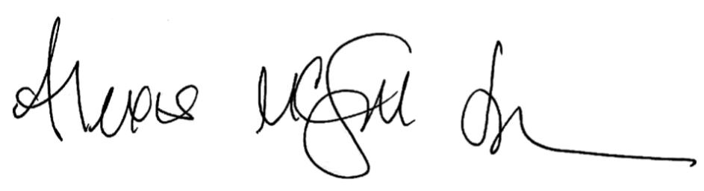
Alexis McGill Johnson
Acting President
Planned Parenthood Action Fund

